COINSTAC Installation Instructions for Mac OS

## Introduction

The Collaborative Informatics and Neuroimaging Suite Toolkit for Anonymous Computation, User Interface (COINSTAC) is software created to foster collaborative research by removing large barriers to traditional data-centric collaboration approaches. It is a desktop application that can be run on the major three operating systems (Windows, Mac, and Linux).

## Installation

To install and run COINSTAC, follow the below instructions:

1. Verify System Requirements
2. Install Docker
3. Download and Run COINSTAC Application

## Verify System Requirements

Use a Mac with OS X 10.12 or higher. Before starting, please check that your computer meets the [System Requirements](https://docs.docker.com/docker-for-mac/install/#what-to-know-before-you-install) for Docker.

## Install Docker

Install Docker from the link below.

<https://store.docker.com/editions/community/docker-ce-desktop-mac>

### Verify Installation

Check that docker is installed by opening a terminal and typing:

docker -v

You should see a similar message, probably with a different version and build:

Docker version 18.03.1-ce, build 9ee9f40

### Verify Docker is Running

Before starting COINSTAC, verify that Docker is running on your computer by using one of the methods below.

#### Method #1

You can verify that Docker is running by hovering over the Docker icon  on your taskbar. You should see a message that Docker is running.

#### Method #2

Open a terminal and type:

docker ps

You should see an output like this:

CONTAINER ID IMAGE COMMAND CREATED STATUS PORTS NAMES

If you see an error message, then you have to start Docker.

### Running Docker

To run Docker:

* Click on the Launchpad  in your taskbar at the bottom of the screen.
* Find Docker in your list of applications and click on it

## Download and Run COINSTAC Application

### Download

To download the COINSTAC application, do the following:

* Go to this page and download the latest release:

<https://github.com/MRN-Code/coinstac/releases/>

* Download the file named **coinstac-darwin-x64.zip**.
* After the download is complete, extract the zip file to a folder on your computer.

### Give Permission to Run Application

After extraction, open the extracted folder and double click on the file named 

You will be prompted with a warning that says this software is from an unverified developer. This warning will only be issued once every time you open a new version of COINSTAC. We have plans to remove it in the future.

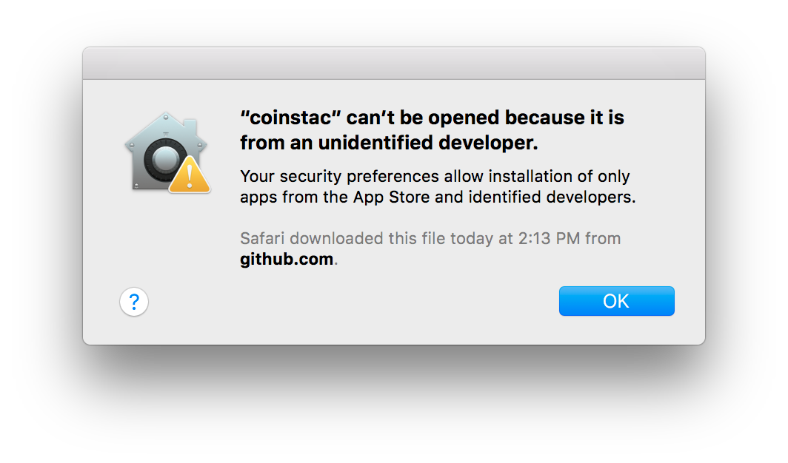

You will have to do the following:

* + Click on the Apple icon A close up of a logo

    Description automatically generated in the top-left corner of your screen
  + Click System Preferences.
  + Click on Security & Privacy.
  + You will see a warning that coinstac was blocked because it was not from an identified developer.

* + Click on the Open Anyway button
    - If that does not work, do the following:
      * Click on the lock in the lower left-hand corner.



* + - * Enter your password.
      * Click on the Open Anyway button
  + Close this window.

### Run Application

Next, go back to the folder where you extracted COINSTAC and double click on the  file again.